**UNIVERSITY OF COMPUTER STUDIES (PYAY)**

**DEPARTMENT OF INFORMATION TECHNOLOGY SUPPORTING AND MAINTENANCE**



**CS-3156**

**Web Development PHP**

**Project Report**

**on**

**Movie Management System**

**Submitted by**

**Group-12**

**Third Year Section (A)**

**March 2024**

**MEMBERS LIST**

|  |  |  |  |  |
| --- | --- | --- | --- | --- |
| No |  | Name | Roll number |  |
| 1 |  | Ma Khin Thiri Mon | PaKaPaTa-002135 | Leader |
| 2 |  | Ma Hsu Myat Mon Kyaw | PaKaPaTa-002148 | Member |
| 3  4 |  | Mg Yair Marn  Mg Aung Phyo Myint | PaKaPaTa-002129  PaKaPaTa-002111 | Member  Member |

**CONTENTS**

|  |  |  |  |  |
| --- | --- | --- | --- | --- |
|  | | | **Page No.** | |
| **ABSTRACT** | | | **i** | |
|  | | |  | |
| **CHAPTER 1** | **INTRODUCTION** | |  |
|  | **1.1 Introductions** | | 1 |
|  | **1.2 Objectives of the System** | | 2 |
| **CHAPTER 2** | **IMPLEMENTATION OF THE SYSTEM** | |  |
|  | **2.1 Home Page** | | 5 |
|  | **2.2 Movie and Movie Detail Pages** | | 6 |
|  | **2.3 Search Page** | | 7 |
|  | **2.4 Login and Sign in Pages** | | 8 |
|  | **2.5 Admin Page** | | 9 |
|  | **2.6 Movie Update Page** | | 10 |
| **CHAPTER 3** | **CONCLUSION** | |  |
|  | **3.1 Advantages of the System** | | 19 |
| **References** |  | | 20 |
|  |  | |  |

**ABSTRACT**

Our Movie Website Management System aimed at enhancing user experience within the realm of online movie platforms. In today's digital age, with the proliferation of streaming services and online movie databases, the need for efficient and user-friendly interfaces has become paramount. Our system discussed herein is designed to address these needs by offering a seamless and engaging platform for users to explore, discover, and engage with movie content.

**CHAPTER 1**

**INTRODUCTION**

* 1. **Introduction**

In the rapidly evolving landscape of digital entertainment, online movie platforms have become integral to how audiences consume and engage with cinematic content. With the proliferation of streaming services and movie databases, the need for efficient and user-friendly website management systems has never been more pressing. This report delves into the development and implementation of a Movie Website Management System (MWMS) aimed at enhancing user experience within the realm of online movie platforms.

The MWMS represents a comprehensive solution designed to streamline the user journey, from discovery to viewing, while prioritizing ease of use and engagement. By providing a robust set of features including user registration, personalized recommendations, intuitive search functionality, comprehensive movie information, user reviews, and ratings, the MWMS aims to cater to the diverse preferences and needs of movie enthusiasts.

* 1. **Objectives of the System**
* Enhance User Experience: The primary objective of the Movie Website Management System (MWMS) is to enhance the overall user experience for individuals accessing movie content online. This involves creating an intuitive and engaging platform that facilitates easy navigation, personalized recommendations, and seamless access to a wide range of movie titles.
* Optimize Content Discovery: The MWMS aims to optimize the process of content discovery by providing users with efficient search as well as personalized recommendations based on their viewing history and preferences. The objective is to help users easily find movies that match their interests and preferences, ultimately increasing user engagement and satisfaction.
* Foster Community Engagement: Building a sense of community among users is another important objective of the MWMS. This involves implementing features such as reviews, and ratings, allowing users to interact with each other and share their thoughts and opinions on movies. By fostering community engagement, the MWMS aims to create a vibrant and active user community around movie content.
* Ensure Reliability and Security: The MWMS places a strong emphasis on ensuring the reliability and security of the platform. This includes implementing robust security measures to protect user data and privacy, as well as ensuring high availability and uptime to minimize downtime and disruptions to user access.

Overall, the objectives of the MWMS are centered around creating a user-centric platform that provides a seamless and enjoyable movie-watching experience while also promoting accessibility, community engagement, and security. By achieving these objectives, the MWMS aims to become a leading destination for movie enthusiasts to discover, explore, and enjoy their favorite films online.

**CHAPTER 2**

**IMPLEMENTATION OF THE SYSTEM**

**2.1 Home Page**

When the users enter the website, the first page they see is the main home page. The

top right corner of this page includes Home, Movie, Search bar, Login and Sign in.

The picture of home page is shown in figure 2.1.

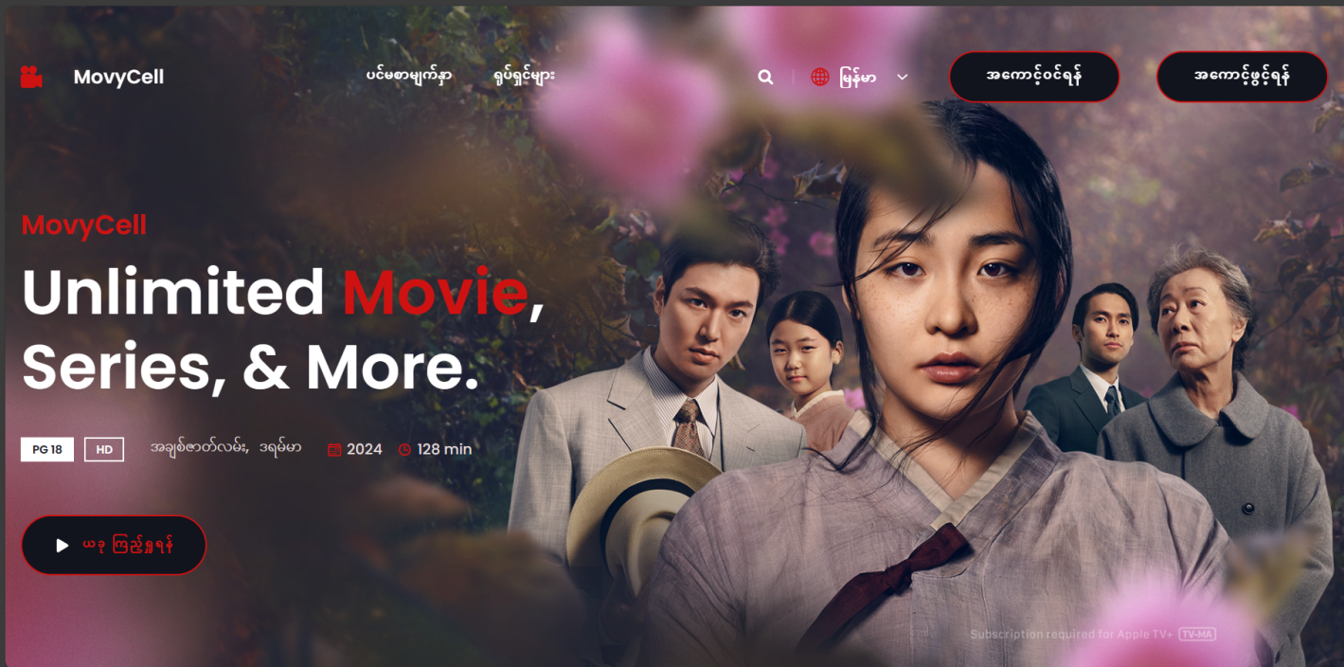

Figure 2.1. Home Page

**2.2 Movie and Movie Detail Pages**

On movie page, users can see many movies that they can watch and download. On movie detail page, users can watch each details of that movies such as description, rankings, trailer, download links. The picture of about page is shown in figure 2.2.

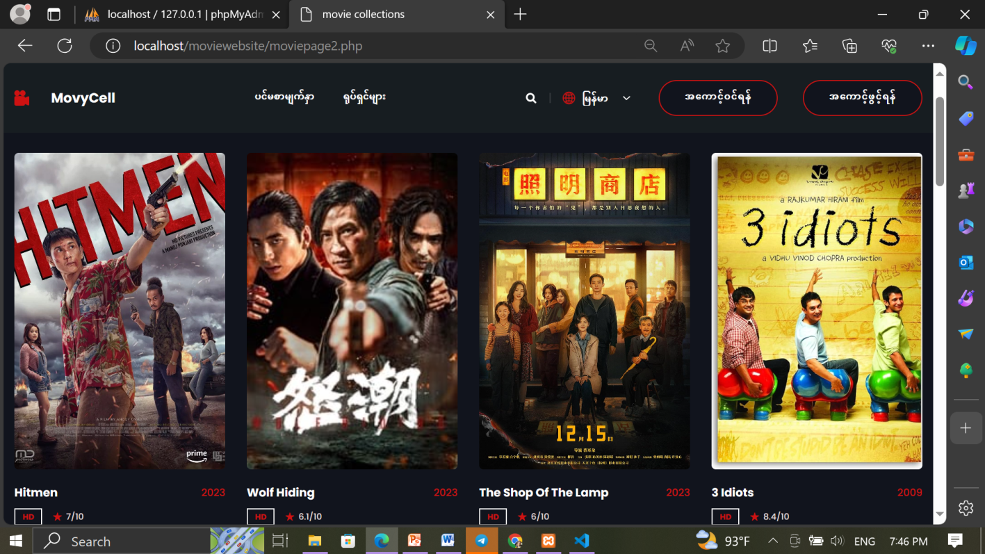

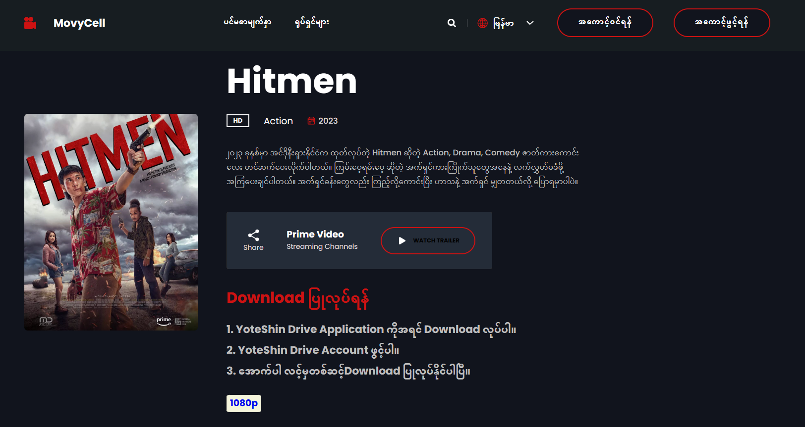

Figure 2.2. Movie and Movie Detail Pages

**2.3 Search Page**

On Search page, users can easily search whatever they want to watch movies. The picture of contact us page is shown in figure 2.3.

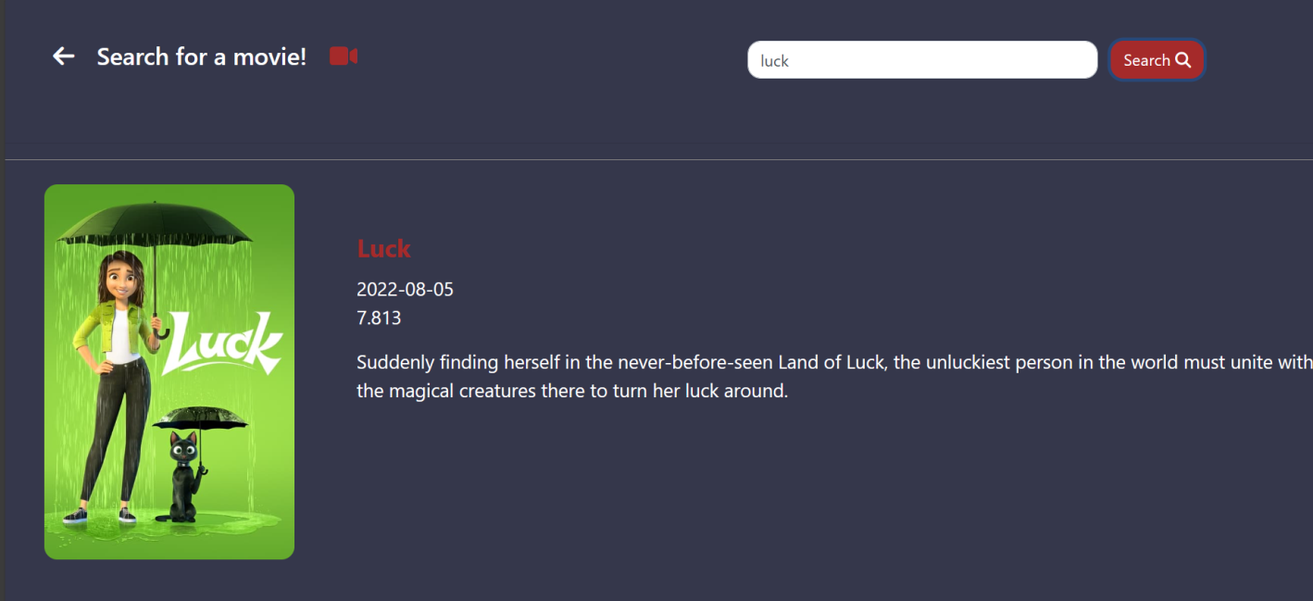

Figure 2.3. Search Page

**2.4 Login and Sign in Pages**

On Login and Sign in Pages, if new user enters to the website, she needs to sign in first to get more functions of our website. If she has already has an account, she just need to login. The picture of page is shown in figure 2.4.

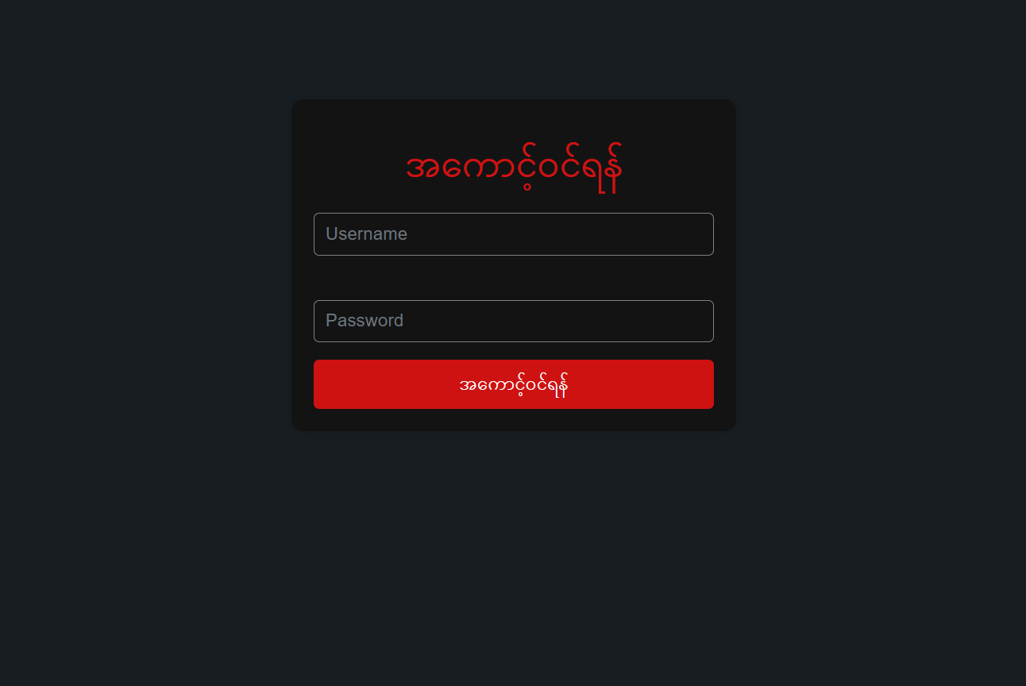

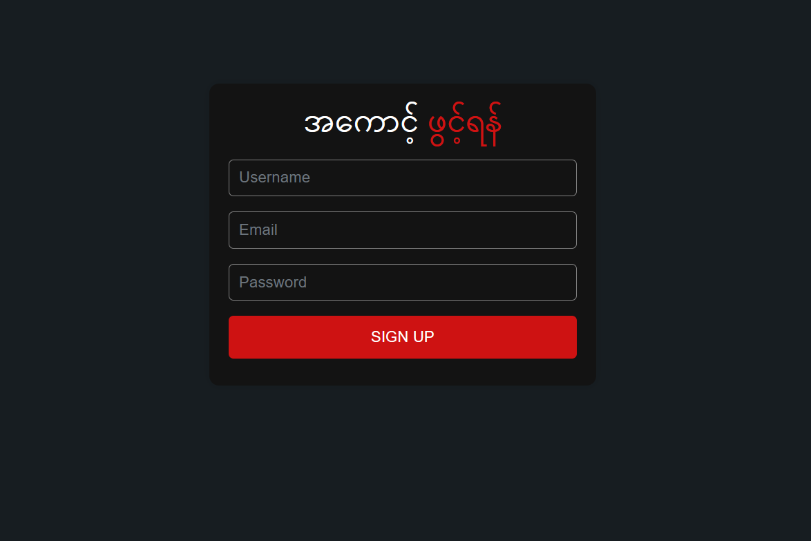

Figure 2.4. Login and Sign in Pages

**2.5 Admin Page**

In the admin page, the admin can see the user’s lists and can upload the new movies and its details. The picture of dashboard page is shown in figure 2.5.

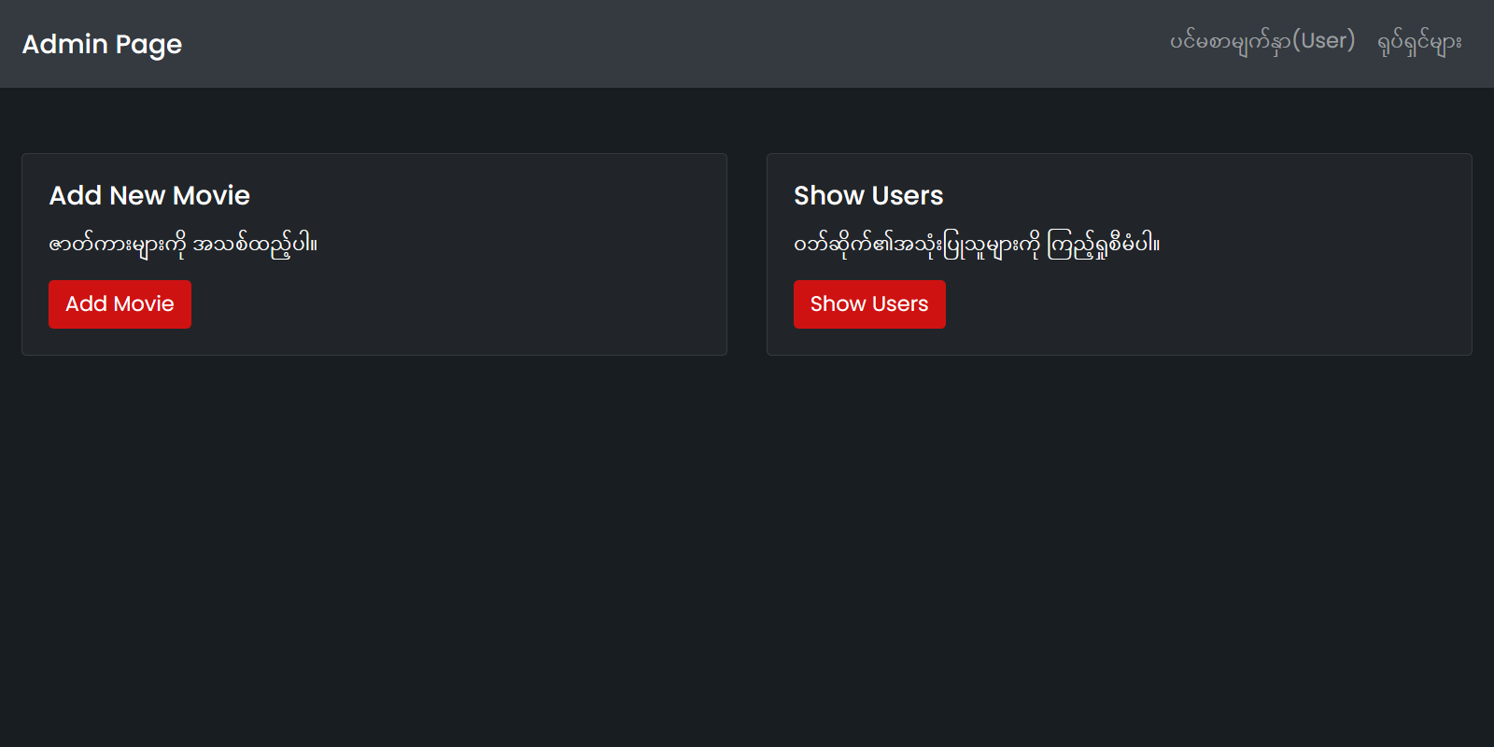

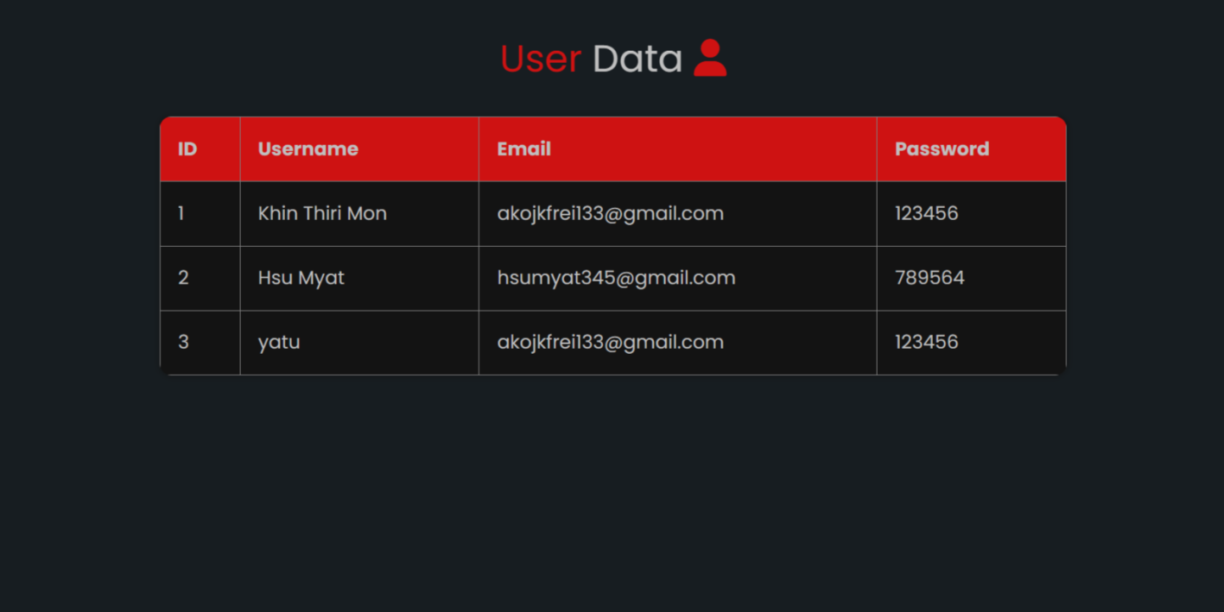

Figure 2.5. Admin Page

**2.6 Movie Update Page**

In Movie Update Page, admin can be update new movies and its details. Moreover, he can manage to the lists. The picture of admin page is shown in figure 2.6.

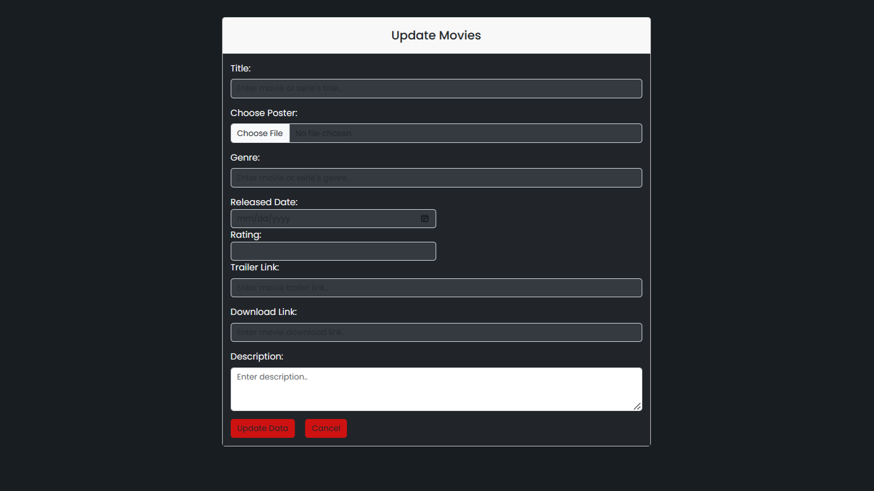

Figure 2.6. Movie Update Page

**CHAPTER 3**

**CONCLUSION**

In conclusion, the Movie Website Management System (MWMS) represents a significant step forward in enhancing the user experience and accessibility of online movie platforms. Throughout this report, we have explored the key functionalities, technological underpinnings, and objectives of the MWMS, as well as its impact on user satisfaction and engagement.

The MWMS has demonstrated its ability to streamline the user journey, from content discovery to viewing, by providing intuitive interfaces, personalized recommendations, and comprehensive movie information. By prioritizing user-centric design principles and leveraging advanced technologies, the MWMS has succeeded in creating a seamless and enjoyable movie-watching experience for users of all demographics.

**3.1 Advantages of the System**

By using this “Movie Website Management System”, people can easily watch and see the information about movies, and admin can easily update and delete data about movies. Viewer can easily find about the details of the movies and search easily. This system helps user to watch international movies with Myanmar Subtitle and can easily download it.

**References**

1. [https://www.google.com](https://www.google.com/)
2. [https://www.youtube.com](https://www.youtube.com/)
3. [https://www.chatgpt.com](https://www.chatgpt.com/)
4. https://www.figma.com